Photography Guide for Photogrammetry

1. Set-up your area
   1. Place a scale bar to the side of the item. It will both act as a guide for the computer to align the photos as well as provide scaling if quantitative analysis is done later.
   2. If possible, adjust your light sources and item so that as few shadows as possible are present on and around the item (preferably no shadows at all).
2. Set-up camera and plan shots
   1. Shoot in RAW image format if you have the storage space so that the camera doesn’t make any edits to the photos. If that’s not possible, use .jpeg.
   2. Take an overview shot showing the entire item at that angle before taking closer shots. Having an overview image helps by giving the software a reference for the entire item.
   3. Make sure at least 50-75% of each photo overlaps the same area as the previous photo. Final photo should overlap at least 50-75% of first photo taken at that angle.
   4. The minimum number of photos will depend on size of item and how close to it you are shooting. Even on a small item though, I have rarely had a good photogrammetric model use less than 100 images.
3. Take photos fully covering the item (360\*) at the following angles (drawing below):
   1. Directly above

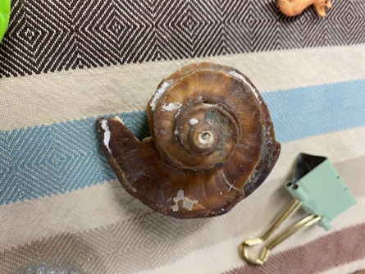

* 1. Angled side
     1. These photos need to overlap partially with the areas covered in direct above & direct side angles to act as a bridge connecting them.

* 1. Direct side

* 1. Angled underneath
     1. Similar to the angled side photos, these photos need to overlap partially with the areas covered in the underside of the item & the direct side angle to act as a bridge connecting them.



Item

Table

1. Flip the item.
2. Take an overview shot of this side, then repeat step 3.
3. Review your images.
   1. Check to make sure that images overlap with each other and that the item is in focus.
   2. Retake any angles necessary. It’s better to take the extra time now than to end up with blurry areas on your model later.

6) Back up the photos. Now they’re ready to use for a photogrammetric model!